**Lab25**

**AWS - Command Line Interface**

Use the below URL to download CLI for Windows

<https://docs.aws.amazon.com/cli/latest/userguide/awscli-install-windows.html>

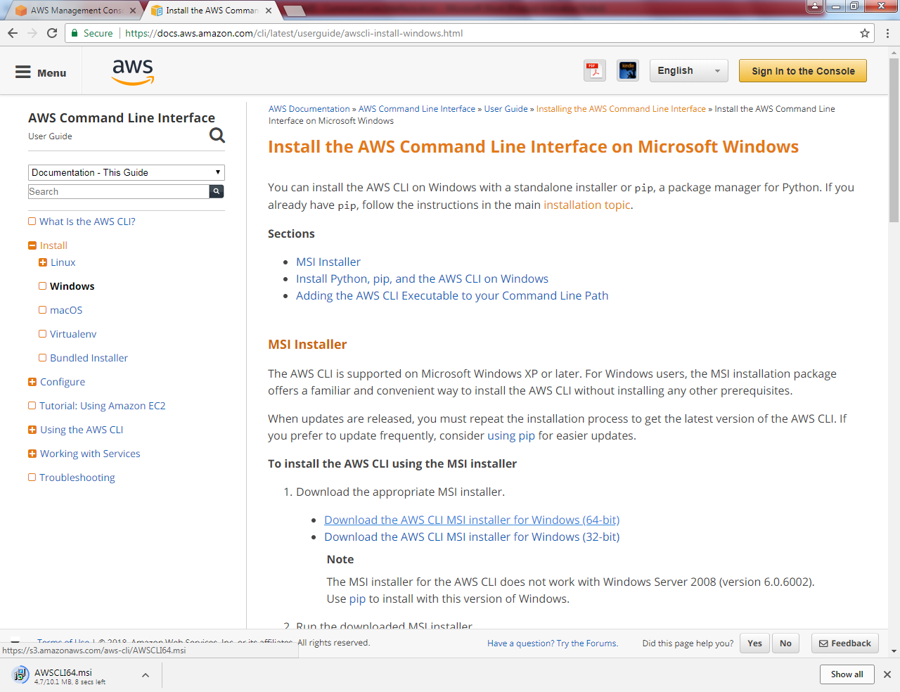

File is getting download.

We need to install in our local machine.

Run AWSCLI64.msi file.

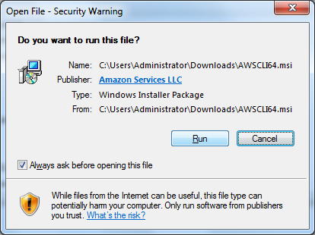

Click “Run”.

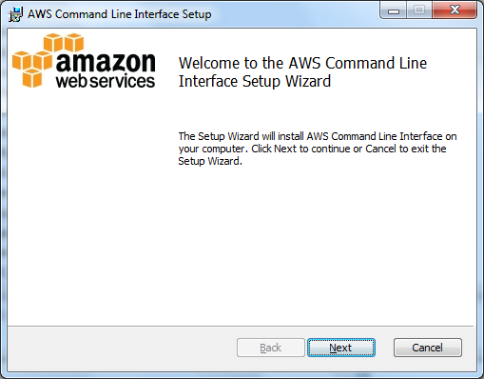

Click “Next”.

Click I accept and click “Next”.

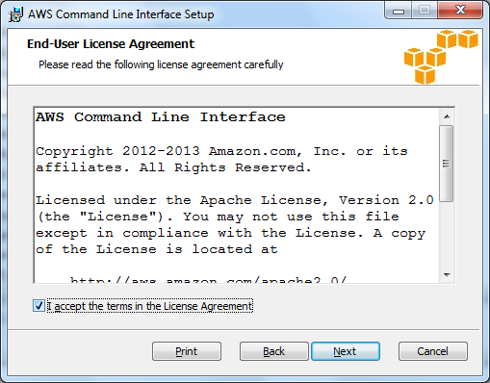

Click “Next”.

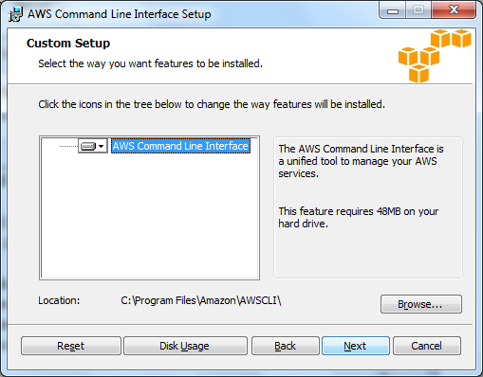

Click “Install”.

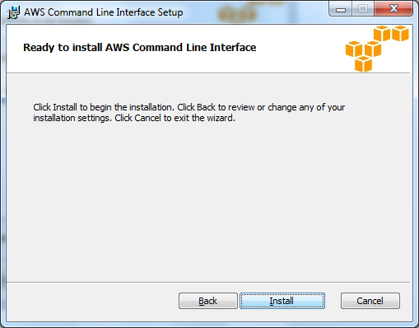

Application installation will be successfully completed.

Type aws and then press enter. You can able to see the commands in command prompt.

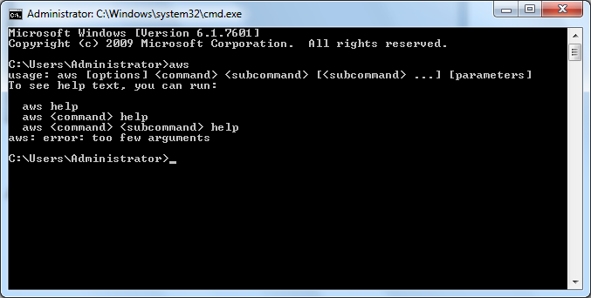

Before Login to CLI, we have required root keys for my account to login to CLI interface.

Click “My Security Credentials”.

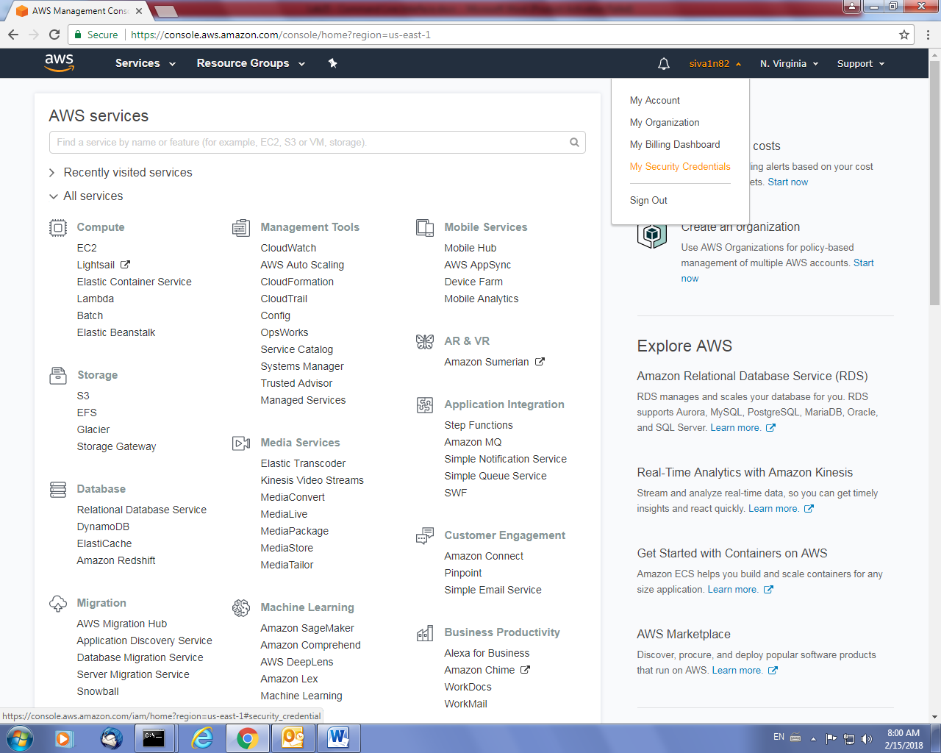

Click “continue to security credentials”.

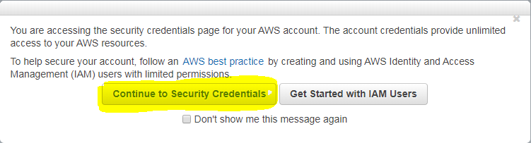

Press “+” key in **Access keys** to expand it.

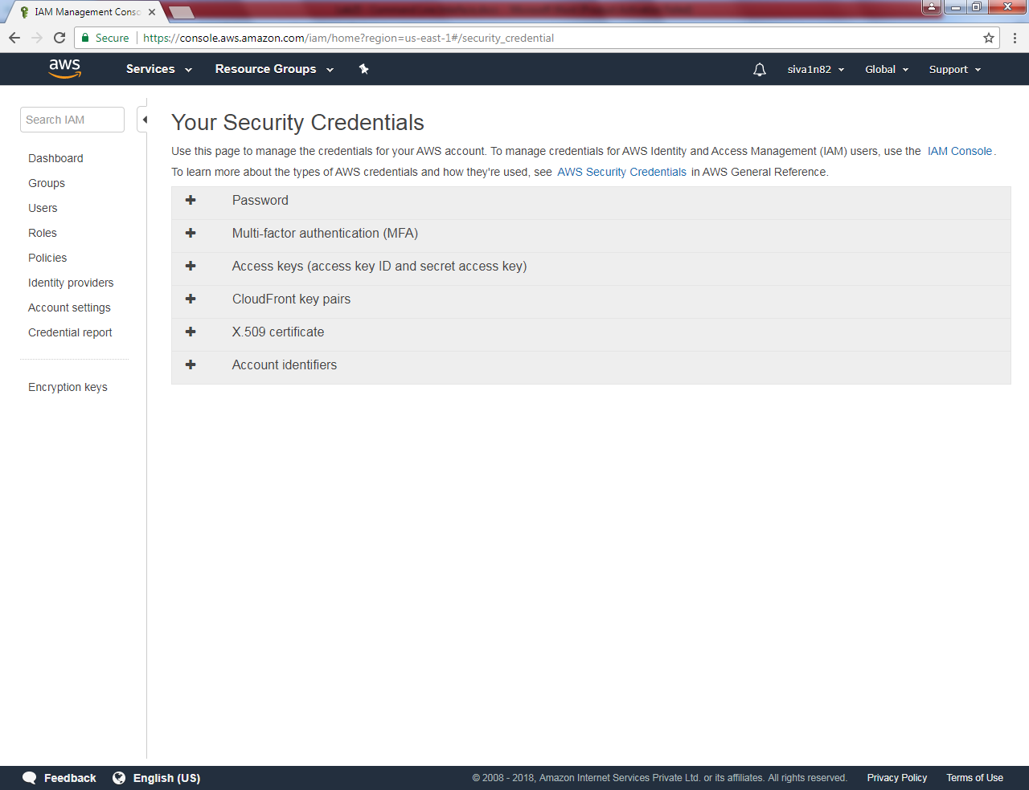

Click “Create New Access Key”.

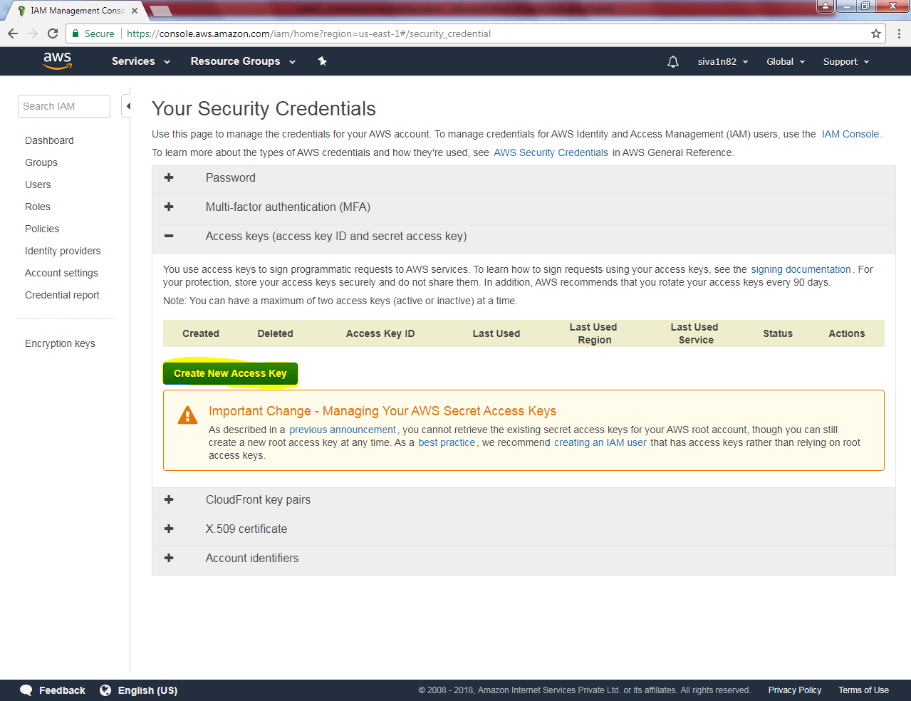

**Click “Show access key” then copy the key into notepad. Because you would not be able to get the password key after this mode / you skip copy from this mode.**

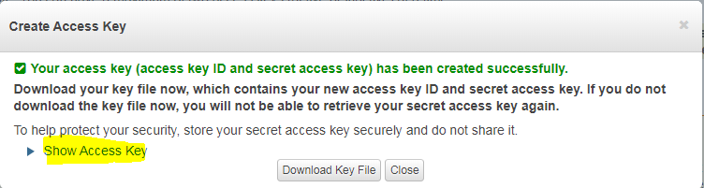

Root keys will be like as below, I have masked Access key ID and Secret access key for security reasons.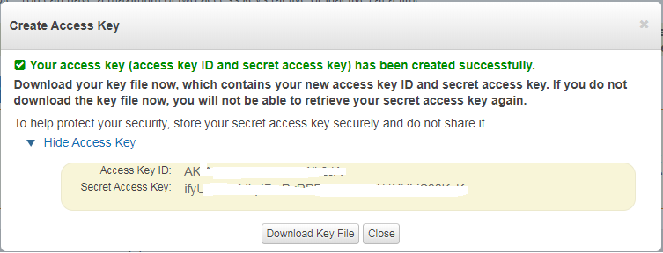

Click “Download Key File” and click “close”.

Now we need to login to command prompt by using Root keys.

Type

**aws configure**

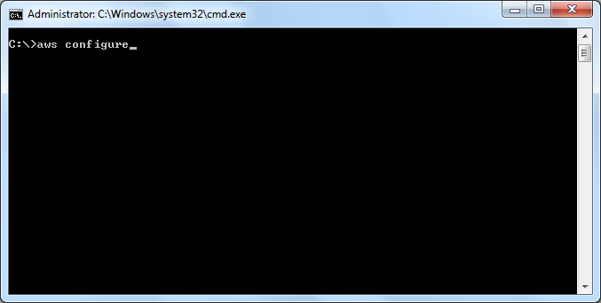

It prompts user id,

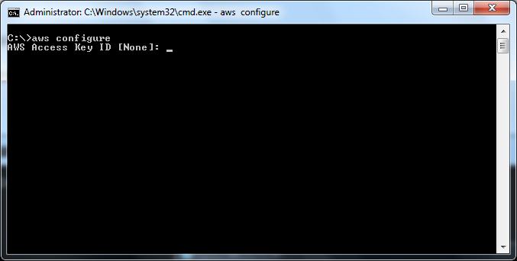

It prompts password, type secret access key

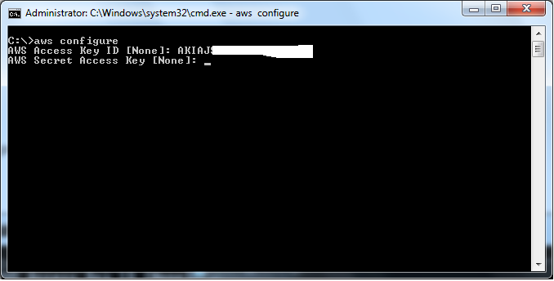

Type region name as us-east-1/where you have connected and type output format json

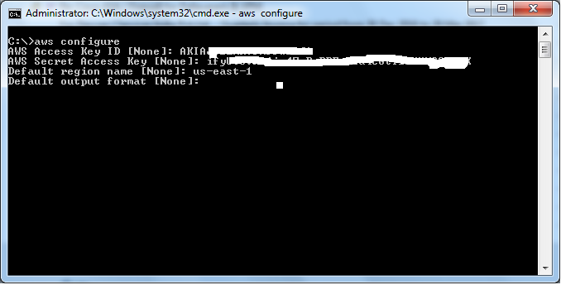

Type

**Aws ec2 describe-instnace-status**

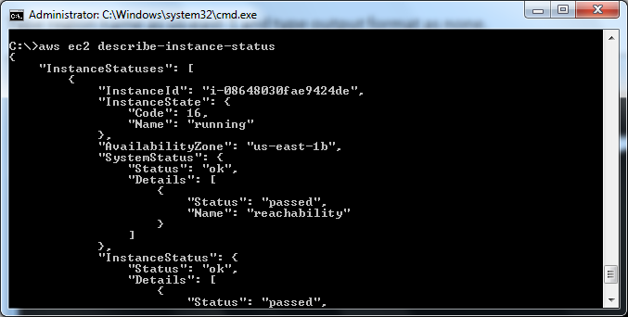

Type

Aws ec2 stop-instances –instance-ids <instance id>

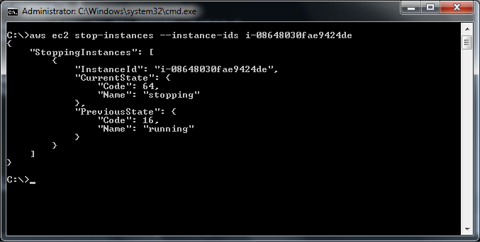

In output you can able to see that instance is getting stop.

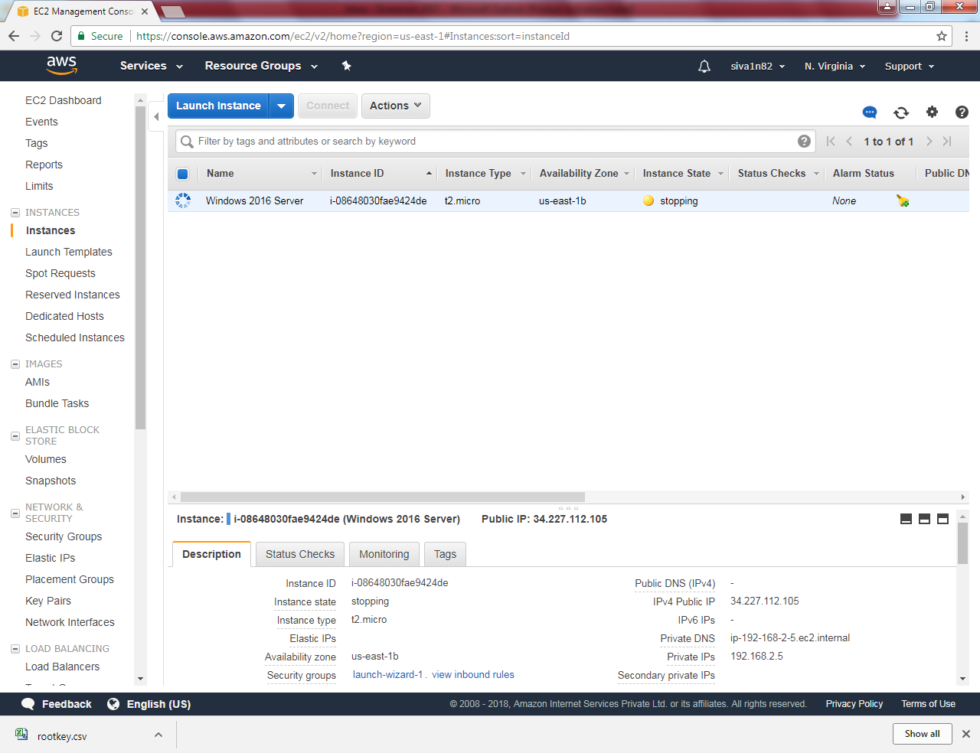

Type

Aws ec2 describe-volumes

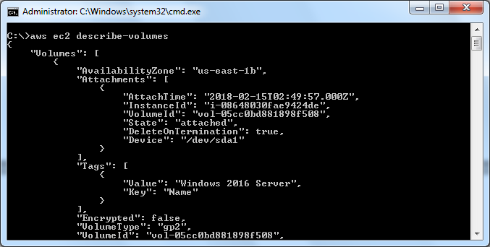

Type

Aws s3 mb s://sansbound

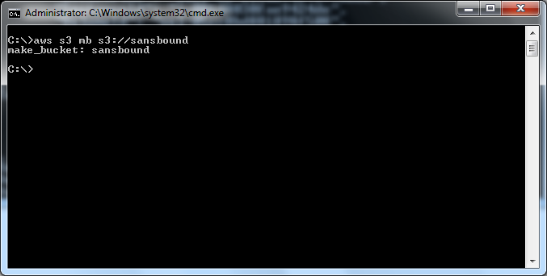

**Go to S3 and able to see that bucket has been created**

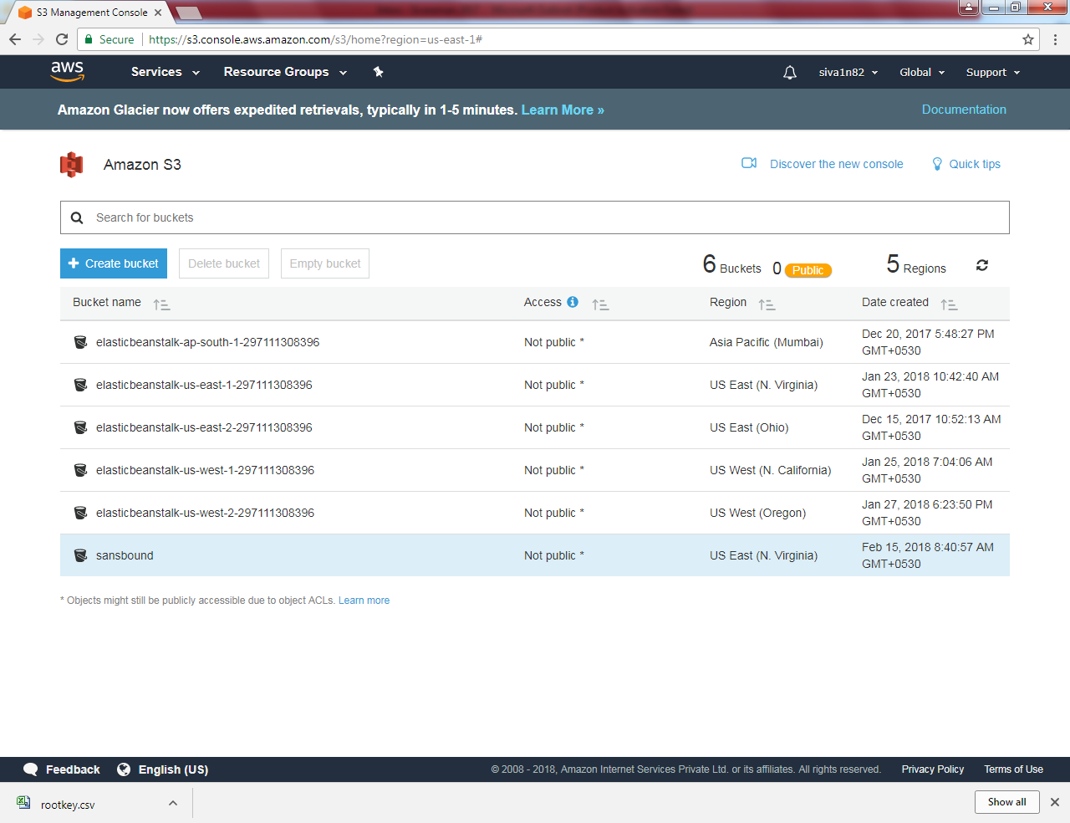

**Type**

Aws s3 ls

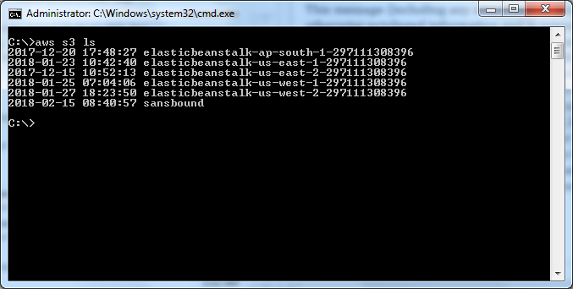

**Type**

Aws s3 rb s3://sansbound

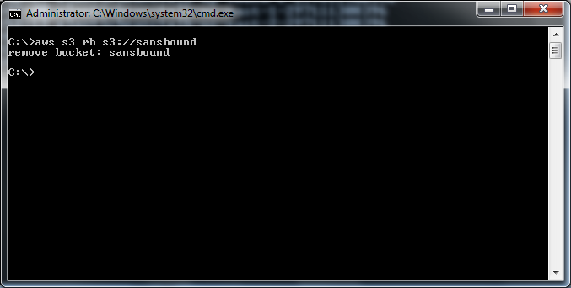

**Type**

Aws s3 mb s3://sansbound2

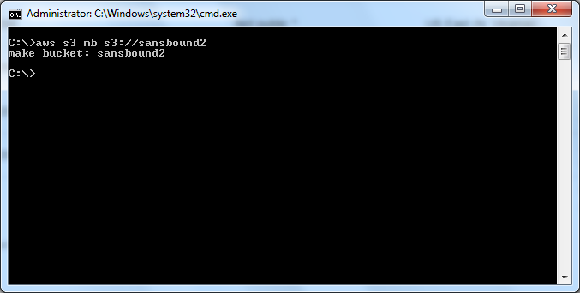

**Type**

Aws s3 cp c:\sansbound.txt s3://sansbound2

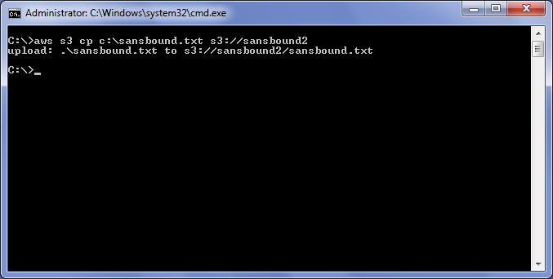

**Type**

Aws s3 sync c:\sansbound s3://sansbound2

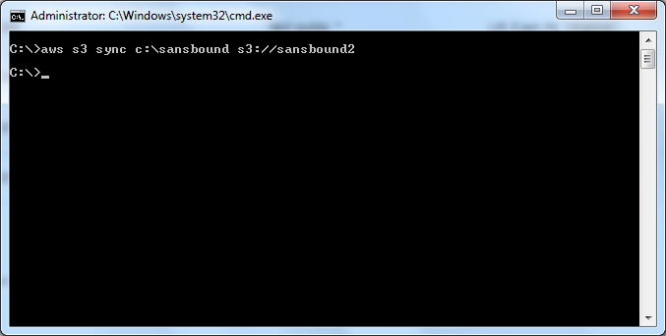

**You can able to see the file in sanbound2 bucket.**

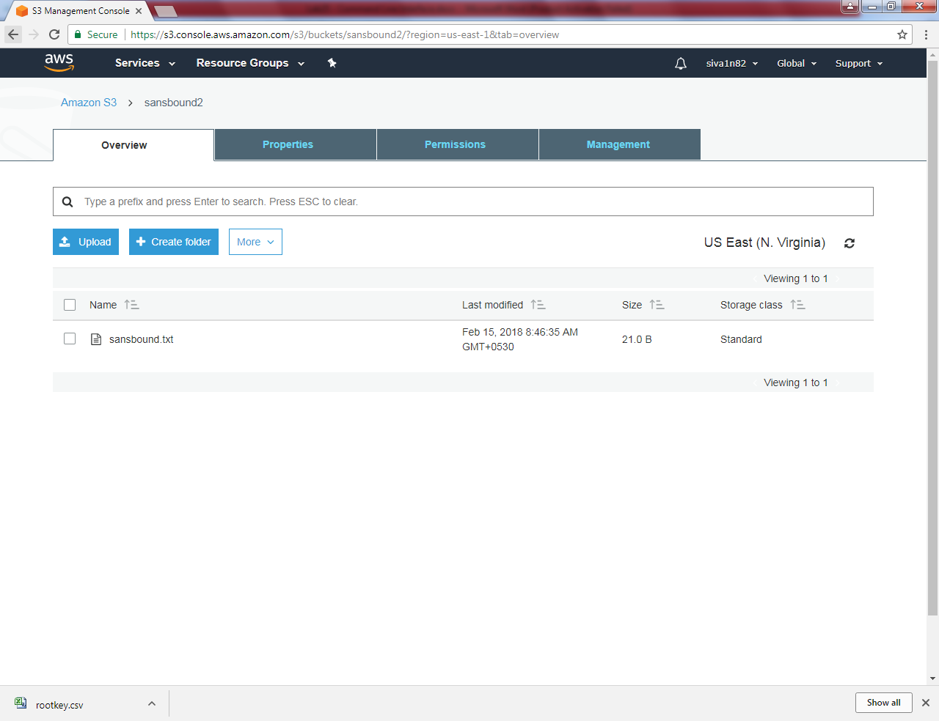

**Now I will copy the files into sansbound2 buckeet.**

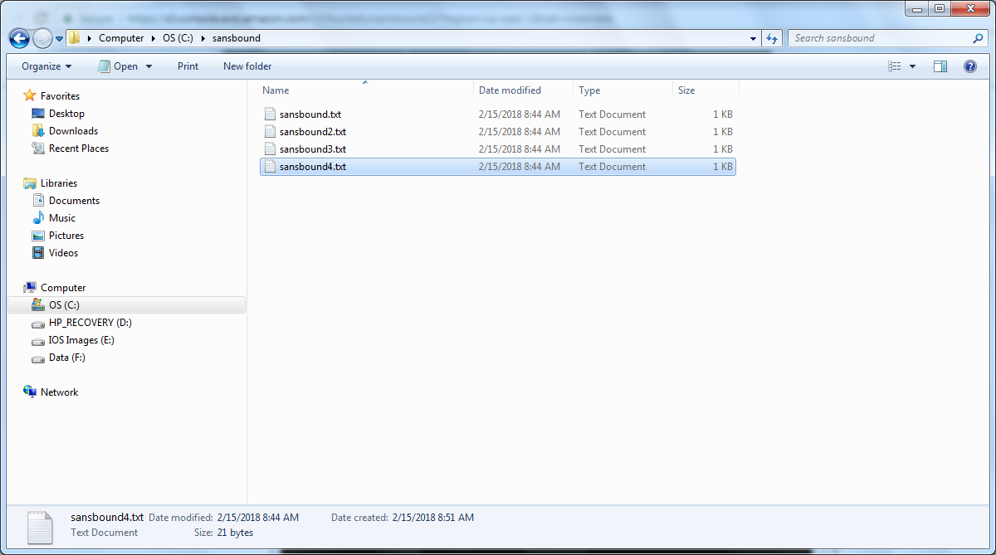

**Type**

s3 sync c:\sansbound s3://sansbound2

